**3/20/2014 RFID Home Security** [**Link to documentation standards**](https://docs.google.com/document/d/186qMQcVW3j20PwgoTO06bwMdU_Xv2gwkIppe6wYbHk8/edit?usp=sharing)

1. Project Reference Number / Title:

140320 RFID Home Security

2. Link to Hardware Order:

[Jims Link to Ebay Order](http://www.ebay.com/itm/141197622655?ssPageName=STRK:MEWNX:IT&_trksid=p3984.m1439.l2649)

[125 KHZ EM4100 RFID Card Read Module RDM630 UART Compatible Arduino.](http://www.ebay.com/itm/141197622655?ssPageName=STRK:MEWNX:IT&_trksid=p3984.m1497.l2649)

[10pcs EM4100 125Khz Readable RFID Tokens Tags](http://www.ebay.com/itm/231109759996?ssPageName=STRK:MEWNX:IT&_trksid=p3984.m1497.l2649)

3. Other Documentation:

[RDM 630 Specification](http://www.seeedstudio.com/depot/datasheet/RDM630-Spec..pdf)

[**Arduino Tutorials – Chapter 15 – RFID**](http://tronixstuff.com/2013/11/19/arduino-tutorials-chapter-15-rfid/)

[**How to connect Arduino and RFID**](http://www.instructables.com/id/Arduino-and-RFID-from-seeedstudio/)

4. Link to Source Documentation/ Actual Documentation:

[RFID(RDM630) and Arduino](http://chalmersphyscomp10.wordpress.com/2010/08/24/rfidrdm630-and%C2%A0arduino/)

# **RFID(RDM630) and Arduino**

Posted on [August 24, 2010](http://chalmersphyscomp10.wordpress.com/2010/08/24/rfidrdm630-and%c2%a0arduino/) by [amirsab](http://chalmersphyscomp10.wordpress.com/author/amirsab/) | [1 Comment](http://chalmersphyscomp10.wordpress.com/2010/08/24/rfidrdm630-and%c2%a0arduino/#comments)

RFID is in use all around us. If you have ever chipped your pet with an ID tag or take a look to the plastic tag in your key ring you use to enter your building, you have used RIFD. ”Radio-frequency identification (RFID) is the use of an object (typically referred to as an RFID tag) applied to or incorporated into a product, animal, or person for the purpose of identification and tracking using radio waves.” [Read more](http://en.wikipedia.org/wiki/Rfid).

You can read RFID tags Using a RFID reader and an Arduino board. Below you can find the schematic for Connecting a RDM630serial RFID reader to an Arduino board.

Here is the [sample code](https://sites.google.com/site/chalmersphyscomp10/Rfid_RDM630.pde?attredirects=0&d=1) that reads RFID tags from RDM630 serial RFID reader and prints them on the serial port. You can see the results by clicking “Serial Monitor” in Arduino program. The LED blinks when the reader reads a tag.

5. Wiring Documentation:

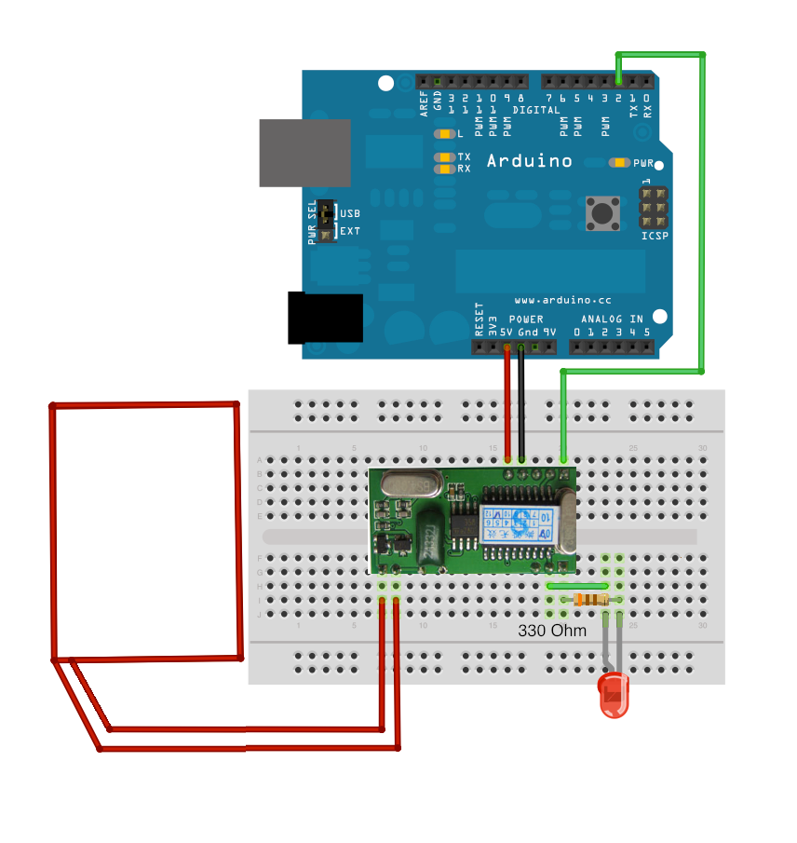

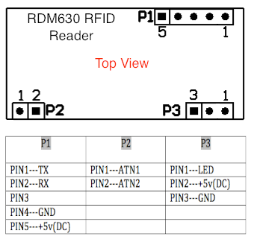

6. ---------------- Project Code: (text format) START -------------------

// Modified code to run with Jim’s RMD6300 courtesy LeRoy.

**#include <SoftwareSerial.h>**

**#define rxPin 2**

**#define txPin 3**

**char code[12];**

**int val = 0;**

**int bytesread = 0;**

**SoftwareSerial RFID = SoftwareSerial(rxPin, txPin);**

**void setup() {**

**Serial.begin(9600);**

**Serial.println("Serial Ready");**

**RFID.begin(9600);**

**Serial.println("RFID Ready");**

**}**

**void loop() {**

**val = 0;**

**bytesread = 0;**

**while(bytesread<12)**

**{**

**val = RFID.read();**

**//Serial.println(val);**

**//delay (1000);**

**if (val == 3)**

**{**

**break;**

**}**

**//Jims RMD6300 returned extended character 152 (insted of null)**

**// Added -1 (equiv 152?) to character inclusion**

**if (val != 2 & val != -1)**

**{**

**code[bytesread] = val;**

**bytesread++;**

**code[bytesread]=-1;**

**}**

**}**

**if (bytesread >= 12)**

**{**

**Serial.print("Tag: [");**

**// Added -1 (equiv 152?) to character inclusion**

**for (int i=0; code[i]!=-1; i++)**

**{**

**Serial.print(code[i]);**

**}**

**Serial.println("]");**

**}**

**}**

**-------------------------------------------START----ORIGINAL CODE DID NOT WORK WITH MY RMD6300--**

**/*------------------------------------------------------------------**

**This is a sample code for RDM630 RFID reader by Spekel(Spekel.se)**

**This work is licensed under a Creative Commons Attribution-NonCommercial-ShareAlike 3.0 Unported License.**

**http://creativecommons.org/licenses/by-nc-sa/3.0/**

**-------------------------------------------------------------------*/**

**#include <SoftwareSerial.h>**

**#define rxPin 2**

**#define txPin 3**

**char code[20];**

**int val = 0;**

**int bytesread = 0;**

**//------------------------------------**

**//create a Serial object RFID**

**SoftwareSerial RFID= SoftwareSerial(rxPin, txPin);**

**void setup()**

**{**

**Serial.begin(9600);**

**Serial.println("Serial Ready");**

**RFID.begin(9600);**

**Serial.println("RFID Ready");**

**pinMode(rxPin, INPUT);**

**pinMode(txPin, OUTPUT);**

**}**

**void loop()**

**{**

**val = 0;**

**bytesread = 0;**

**while(bytesread < 12)**

**{**

**// read 12 digit code**

**val = RFID.read();**

**if(val == 3)**

**{ // if header or stop bytes before the 10 digit reading**

**break; // stop reading**

**}**

**if(val != 2)**

**{**

**code[bytesread] = val; // add the digit**

**bytesread++; // ready to read next digit**

**code[bytesread] = '\0'; // add the NULL**

**}**

**}**

**if(bytesread >= 12)**

**{ // if 12 digit read is complete**

**Serial.print("Tag: [");**

**for(int i=0; code[i]!='\0' ; i++)**

**{**

**Serial.print(code[i]);**

**}**

**Serial.println("]"); //print the whole 13 bytes**

**}**

**}**

**-------------------------------------------END----ORIGINAL CODE DID NOT WORK WITH MY RMD6300--**

7. --------------------- Project Code: (text format) END ---------------------

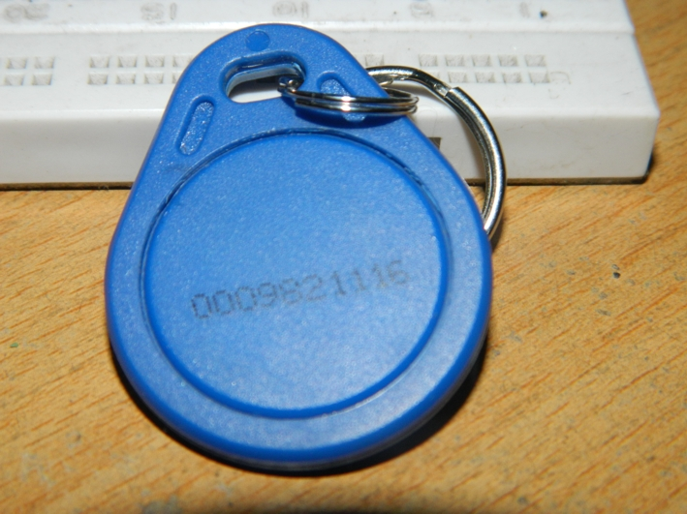

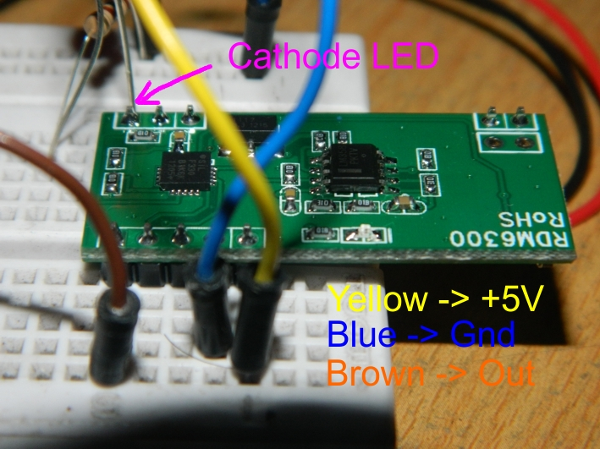

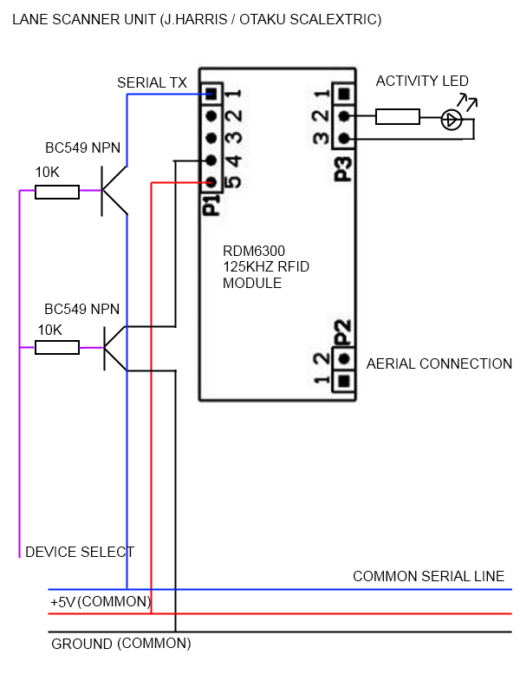

**/*------------------------------------------------------------------**

**8. Marked Up Code---------------------------------------------------------------------------**

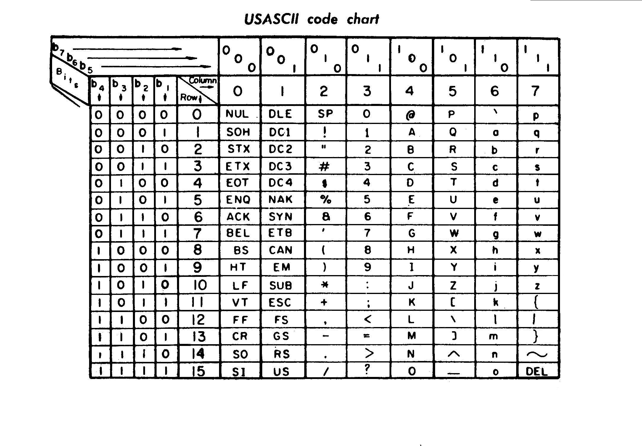

**This is a sample code for RDM630 RFID reader by Spekel(Spekel.se)**

**This work is licensed under a Creative Commons Attribution-NonCommercial-ShareAlike 3.0 Unported License.**

**http://creativecommons.org/licenses/by-nc-sa/3.0/**

**-------------------------------------------------------------------*/**

**#include <SoftwareSerial.h>**

**#define rxPin 2**

**#define txPin 3**

**char code[20]; \\Character array**

**int val = 0;**

**int bytesread = 0;**

**//------------------------------------**

**//create a Serial object RFID**

**SoftwareSerial RFID= SoftwareSerial(rxPin, txPin);**

**void setup()**

**{**

**Serial.begin(9600);**

**Serial.println("Serial Ready");**

**RFID.begin(9600);**

**Serial.println("RFID Ready");**

**pinMode(rxPin, INPUT); \\Mode set for RX**

**pinMode(txPin, OUTPUT); \\Mode set for TX**

**}**

**void loop()**

**{**

**val = 0;**

**bytesread = 0;**

**while(bytesread < 12) \\Loop until bytes read >= 12**

**{**

**// read 12 digit code**

**val = RFID.read(); \\ Read input one character at a time.**

**if(val == 3) // EOT - If End Of Text found exit loop**

**{ // if header or stop bytes before the 10 digit reading**

**break; // stop reading**

**}**

**if(val != 2) // SOT - If Start Of Text NOT found, add character to array, set null to**

**\\ indicate end of array**

**{**

**code[bytesread] = val; // add the digit**

**bytesread++; // ready to read next digit**

**code[bytesread] = '\0'; // add the NULL (sets last byte to C style end of \\ \\Character array)**

**}**

**}**

**if(bytesread >= 12) \\12 bytes read time to print**

**{ // if 12 digit read is complete**

**Serial.print("Tag: [");**

**for(int i=0; code[i]!='\0' ; i++) \\Print all NON null value array elements**

**{**

**Serial.print(code[i]);**

**}**

**Serial.println("]"); //print the whole 13 bytes**

**}**

**}**